Name: Madireddy Mahesh

Batch: March 1st 2022

Tutor: Raham shaik

Project Name: Static webhosting

* **Static Webhosting using AWS S3:**

1. Created the S3 bucket with the name (static-webhosting-s3)
2. After the S3 Bucket was created click on the bucket and upload Html files.

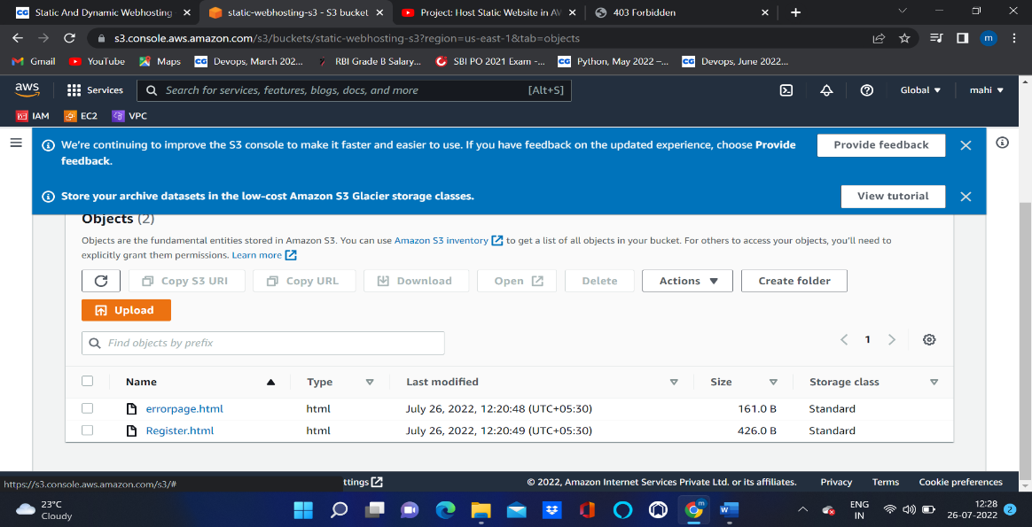

1. Go to Bucket properties and go to static webhosting properties click on enable .
2. **After enable the properties of static webhosting then go to the bucket select the files inside the bucket and go to actions make public access.**

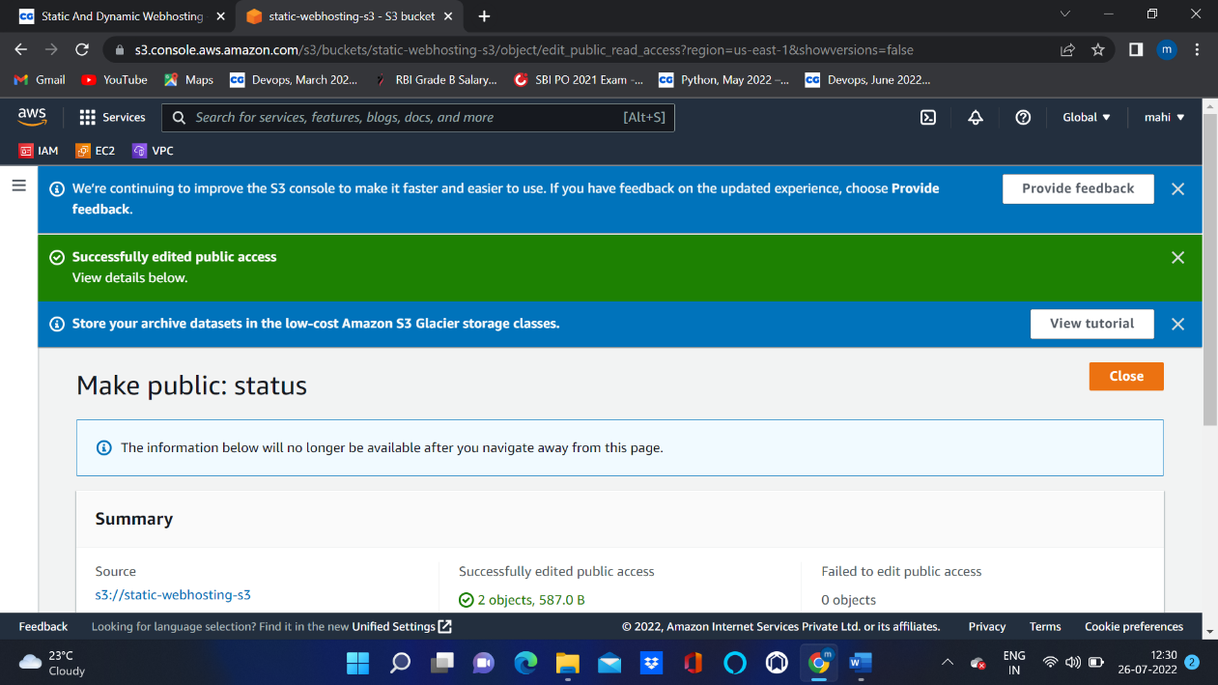

1. **Go to properties and click on static webhosting there we can see the link copy that link paste it into new tab .**

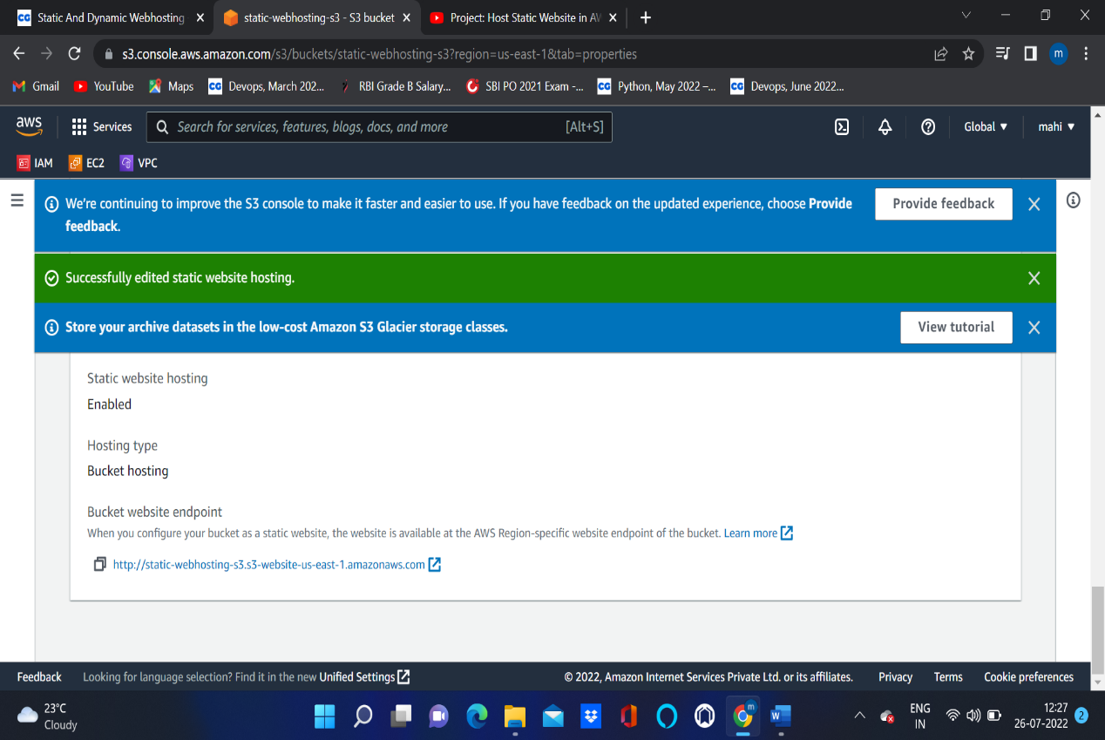

1. **We can see our web page.**